Project Structure

*Project Format*:

Use of project format involves assembling a team of programmers who conduct a project from start to finish. Project team members do the product definition, designing, implementation. Testing, conducting the project reviews and preparing the supporting documents.

After completing these phases some of the team members will stay with the product during installation and maintenance while others will be moved on to a new project.

*Functional Format*:

In functional format a different team of programmers performs each phase of the project. The team members performing one particular phase generate the work products for that phase. It is then passed on to the next team who in turn generate the work products for the phase.

The various teams along with the function performed by them and the work products generated by them are given in the following table.

**Team Function or work performed**

1. Planning and Analysis team system Definition  
 project Plan

2. Product Definition team performs software requirements analysis   
 prepares Software Requirement Specification

3. Design team designs the product to confirm with the System  
 definition and Requirement Specification

4. Implementation team Implements, debugs and unit tests the product

5. System testing team does the integration testing and acceptance   
 testing.

6. Quality Assurance team certifies the quality of all work products.

7. Maintenance team maintains the product during its useful life.

Planning and analysis team prepares system Definition and project plan. These work products are then passed to the Product Definition team. These work products are passed to the next team in the same way as they are evolved.

A variation on the functional format involves three teams.

1. Analysis team
2. Design and implementation team
3. Testing and maintenance team

*Matrix Format*:

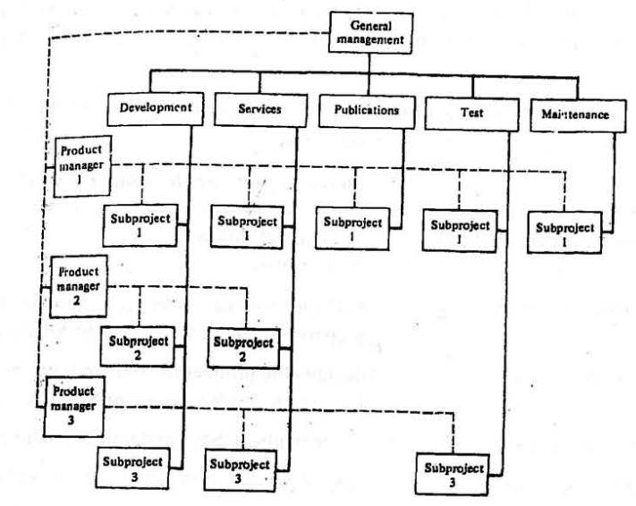

Fig 1: Product – Function Matrix Organization

Each function has its own management team and a group of specialists who are concerned only with that function. The organization is having different team specialists for each of the function of the organization. The various functions of the organization are:

1. Development
2. Services
3. Publication
4. Test
5. Maintenance